Glens of Antrim Medical Centre

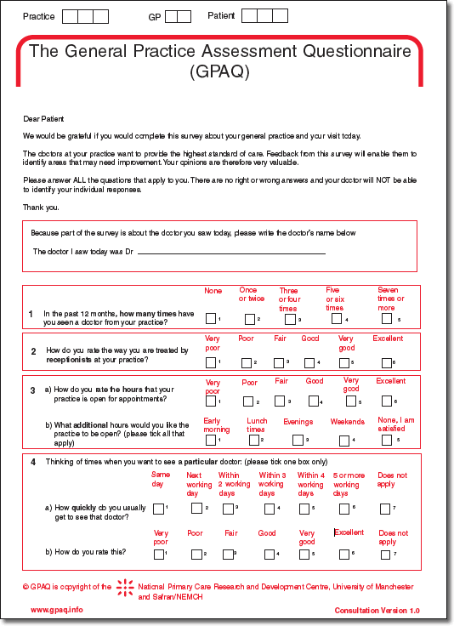
During December 2008 and January 2009 the Practice carried out a patient satisfaction survey. The practice would like to take this opportunity to thank all patients who took the time to provide us with this valuable feedback.
A total of 134 questionnaires were returned. A summary of the findings, are detailed below.
A copy of the full report can be obtained from the reception desk. Alternatively please visit www.glensofantrimmedicalcentre.co.uk for full details.

Area | GPAQ National  Benchmark | Practice  Score
Satisfaction with receptionists | 77 | 89
Satisfaction with opening hours | 67 | 72
Satisfaction with availability of particular doctor | 60 | 70
Satisfaction with availability of any doctor | 69 | 78
Satisfaction with waiting times at Practice | 57 | 70
Satisfaction with phoning through to Practice | 59 | 59
Satisfaction with phoning through to doctor for advice | 61 | 68
Satisfaction with continuity of care | 69 | 76
Satisfaction with doctor’s questioning | 81 | 85
Satisfaction with how well the doctor listens | 84 | 86
Satisfaction with how well doctor puts patient at ease | 84 | 88
Satisfaction with how much doctor involves patient | 81 | 86
Satisfaction with doctor’s explanations | 83 | 88
Satisfaction with time doctor spends | 80 | 85
Satisfaction with doctor’s experience | 84 | 86
Satisfaction with doctor’s caring and concern | 84 | 88
Ability to understand problem after visiting doctor | 69 | 79
Ability to cope with problem after visiting doctor | 66 | 76
Ability to keep healthy after visiting doctor | 62 | 74

